REPUBLIQUE OF CAMEROON
PEACE-WORK-FATHERLAND
*****************
AFRICAN INSTITUTE OF COMPUTERS SCIENCES
*****************
BP: 13 719 Yaoundé (Cameroun)
Tel: (237) 22 72 99 57 / (237) 22 72 99 58
Site Web: www.iaicameroun.com

REPUBLIQUE DU CAMEROUN
PAIX -TRAVAIL-PATRIE
*****************
INSTITUT AFRICAIN D’INFORMATIQUE
*****************
BP : 13 719 Yaoundé (Cameroun)
Tel: (237) 22 72 99 57 / (237) 22 72 99 58
Site Web: www.iaicameroun.com

JAVA PROJECT
GROUP 15: TOY AND GAME STOCK MANAGMENT

GROUP MEMBERS
- NTI MEKONGO ONANA THIERRY HENRY 60%
- NGOUANE JESSICA 40%

SUPERVISOR
Mr. FOMEKONG

ACADEMIC YEAR 2024 - 2025
Table of Contents
INTRODUCTION 3
Purpose 3
Scope 3
Dynamic diagrams 4
1 Use case diagram 4
1.1 Specific use case of manage account 5
1.2 Specific use case of manage products 5
2 Activity diagram 6
2.1 Activity diagram of Authentication 6
2.2 Activity diagram of Add product 7
3. Sequence Diagram 8
3.1 Sequence diagram of Authentication 8
3.2 Sequence diagram of Add product 9
4 Communication diagram 10
4.1 Communication diagram for authentication 10
4.2 Communication diagram for Add product 11
5. State Machine diagram 12
5.1 State machine of Stock 12
5.2 State machine of Report 12
Static diagrams 13
1 Class diagram 13
2. Object diagram 14
3. Package diagram 15
4. Component diagram 16
5. Deployment diagram 17
Conclusion 18

INTRODUCTION

Purpose
This report outlines the design and functionality of a stock management application tailored for the toy and game industry. The app enables efficient management of products, stock levels, user accounts, and provides alerts for low-stock situations.

Scope
Key functionalities include:
- Manage product: add, update, and remove toy/game products.
- Manage stock: monitor and adjust stock levels across locations.
- Manage account: control user access with role-based permissions.
- View low stock level: identify and address products nearing depletion.
- Manage supplier: add, update, and remove suppliers.

Dynamic diagrams

Use case diagram
This diagram illustrates the interaction between the actors and the system.

Specific use case of manage account

Specific use case of manage products

Activity diagram
This diagram represents the activities and actions of a system, including the flow of control and data.

Activity diagram of Authentication

Activity diagram of Add product

3. Sequence Diagram
It shows the sequence of messages exchanged between the objects.

3.1 Sequence diagram of Authentication

3.2 Sequence diagram of Add product

4 Communication diagram
It focuses on the relationships and interactions between objects, highlighting the messages exchanged between them.

4.1 Communication diagram for authentication

4.2 Communication diagram for Add product

5. State Machine diagram
It illustrates the states and transitions of an object or a system.

5.1 State machine of Stock
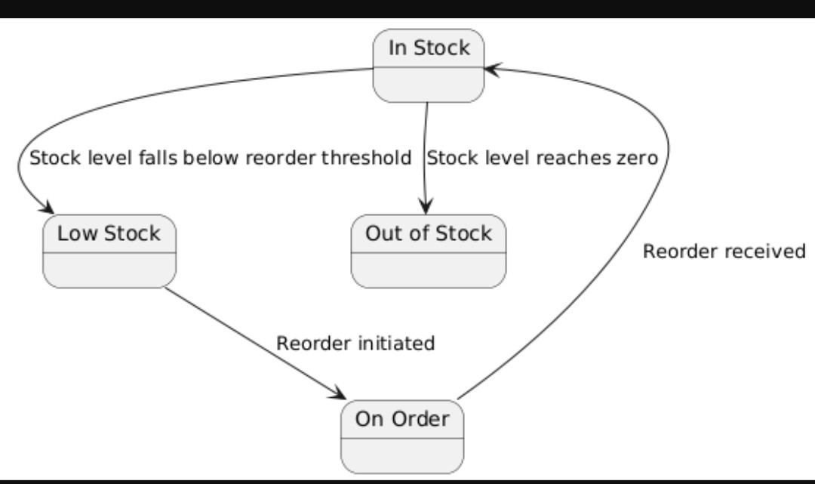

5.2 State machine of Report
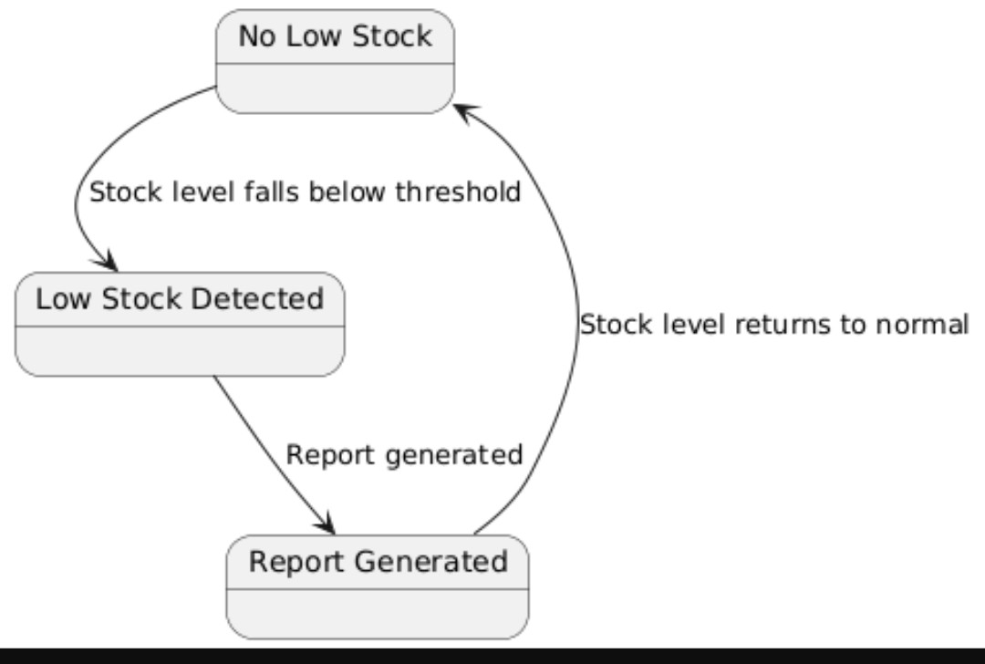

Static diagrams

Class diagram
Shows the classes, attributes, operations, and relationships between classes.

2. Object diagram
Represents a snapshot of the objects in a system at a particular point in time.

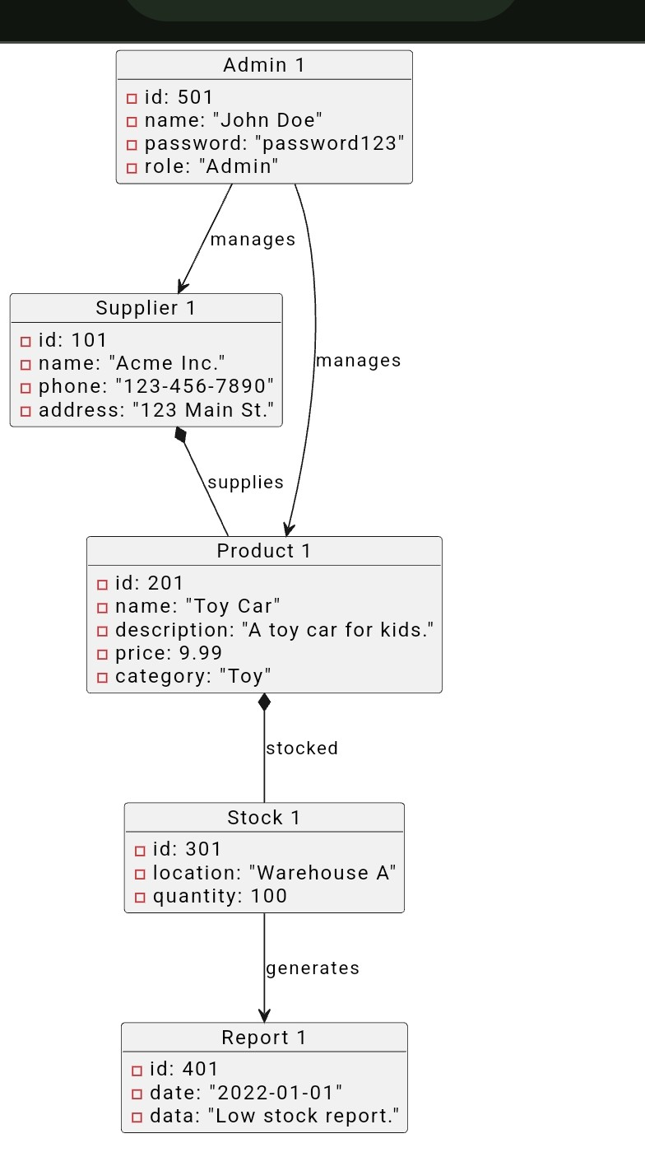

3. Package diagram
It represents the organization of classes and other elements into packages.
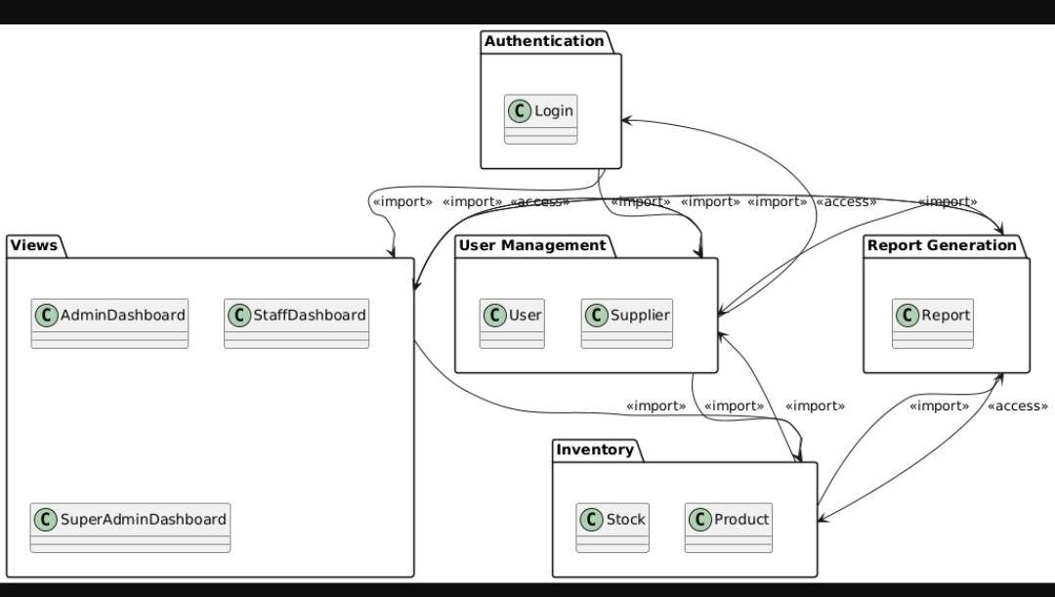

4. Component diagram
It illustrates the components of a system, their relationships and interfaces.
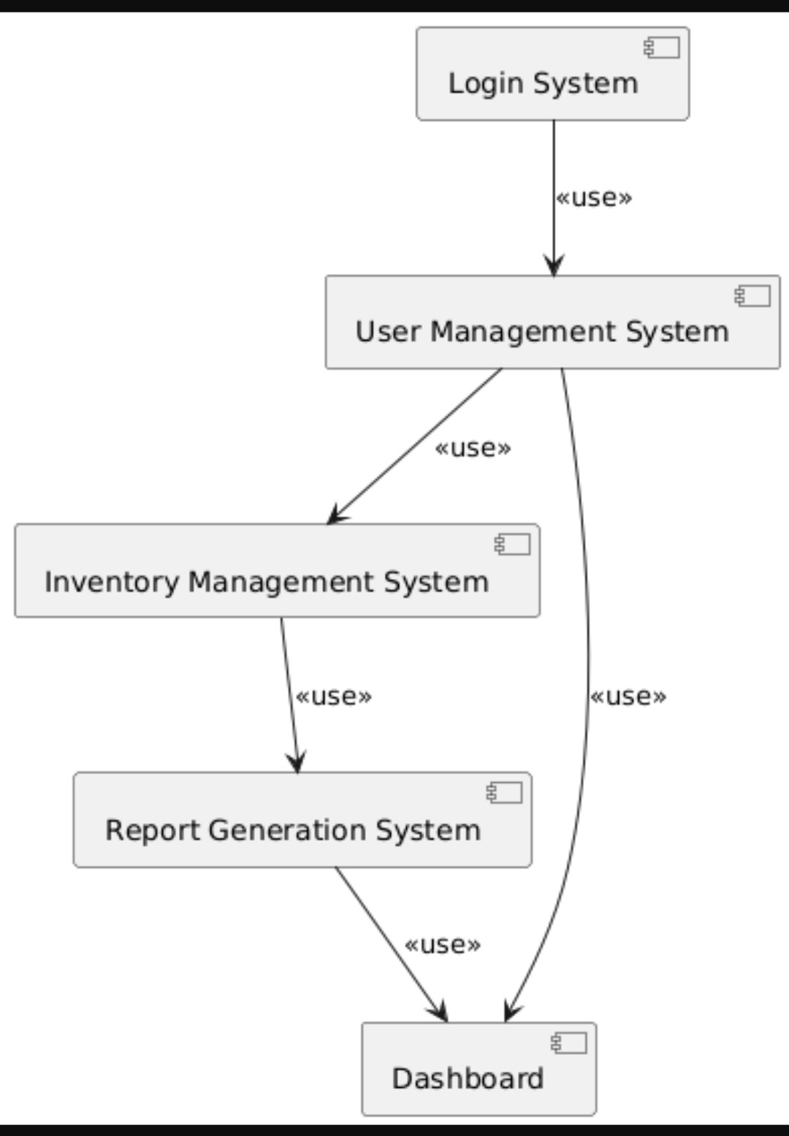

5. Deployment diagram
It shows the physical deployment of components on nodes (hardware or software).
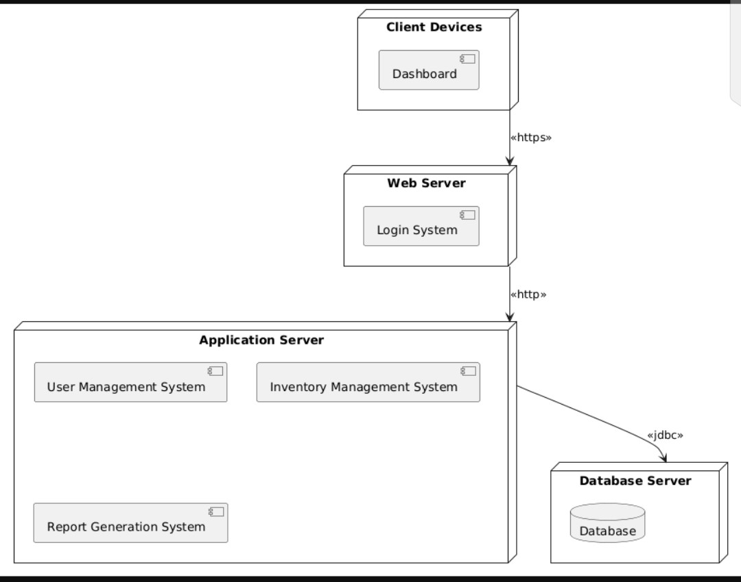

Some screenshots of the different java Jframes
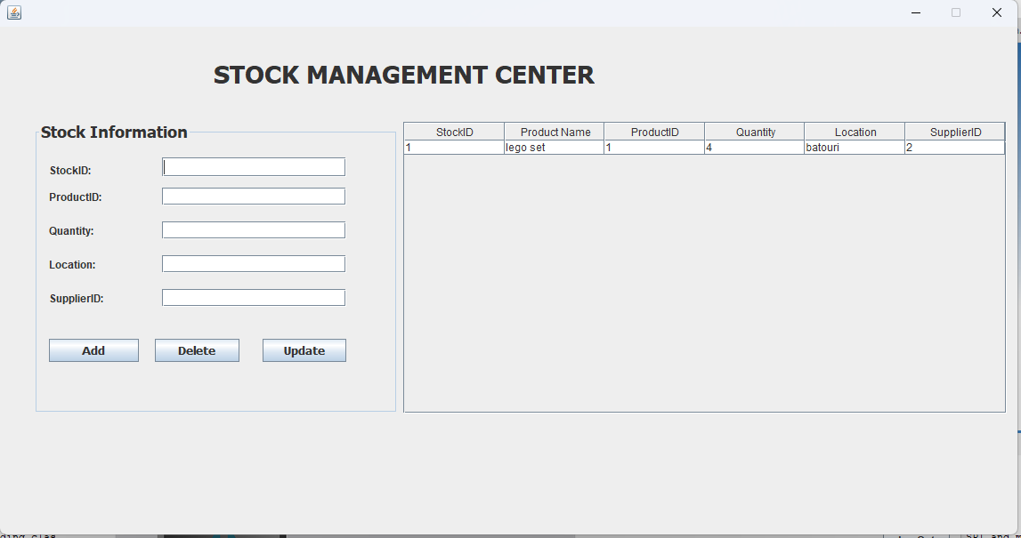
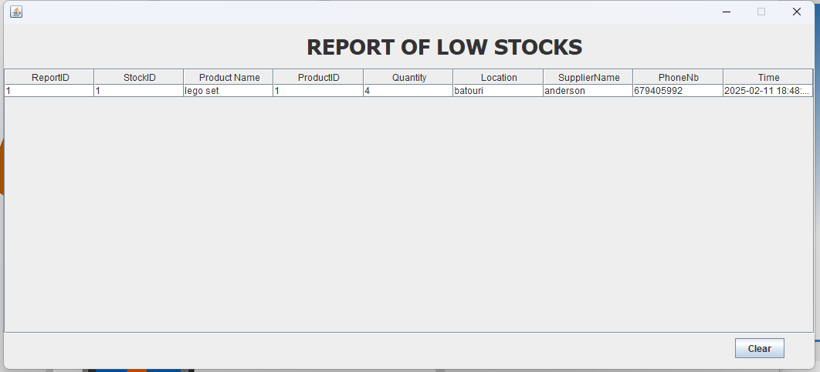
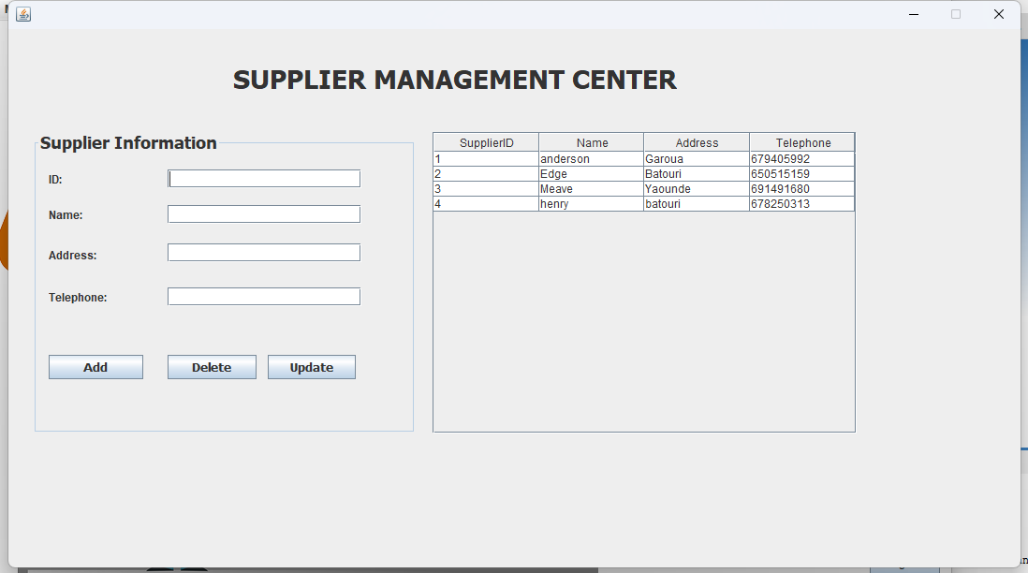
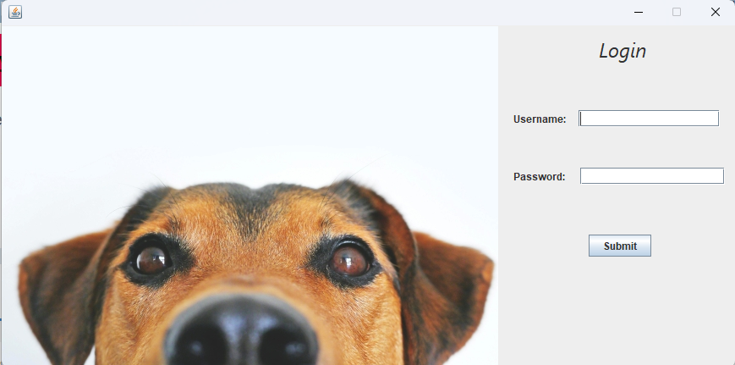
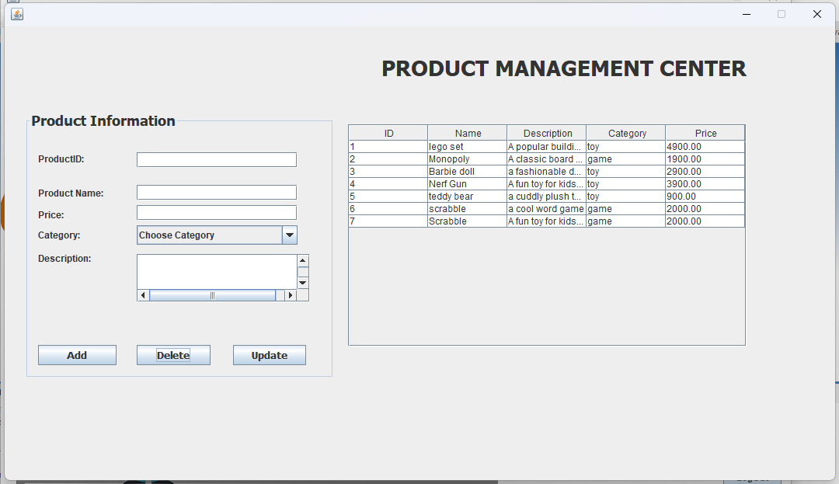
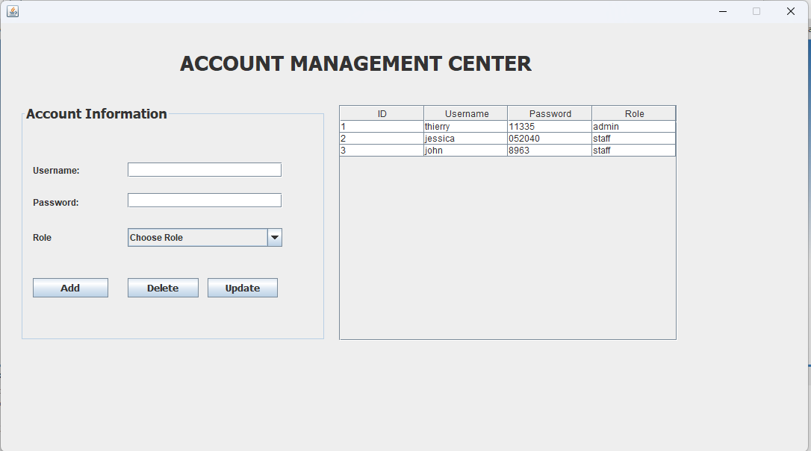
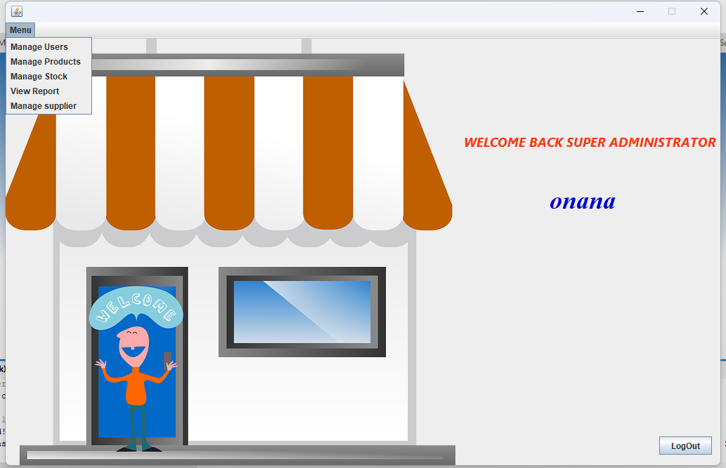

Conclusion
The toy and game stock management app is a comprehensive and user-friendly solution designed to streamline inventory management for toy and game retailers. By providing real-time tracking of stock levels, automated reporting, and intuitive management tools, this app enables businesses to optimize their inventory, reduce waste, and improve customer satisfaction. With its robust features set and scalable architecture, the toy and game stock management app is an ideal solution for retailers of all sizes. By leveraging this app, businesses can gain a competitive edge in the market, drive growth, and achieve long-term success.

